Meta Title:
Home Remodeling & Construction Services in Houston
Meta Description:
Are you looking for the best Home Remodeling & Construction Services in Houston? Contact Houston Custom Carpets, the Best Remodeling & Construction company.


Home Remodeling & Construction Services in Houston (H1)
Providing Residential & Commercial General Contracting Services Since 1988.
Welcome to Houston Custom Carpets – the best company for remodeling in Houston. Our company provides professional Home Remodeling & Construction Services in Houston with a focus on the client’s requirements.


Welcome to

Houston Custom Carpets (H2)
Remodeling & Construction(H3)

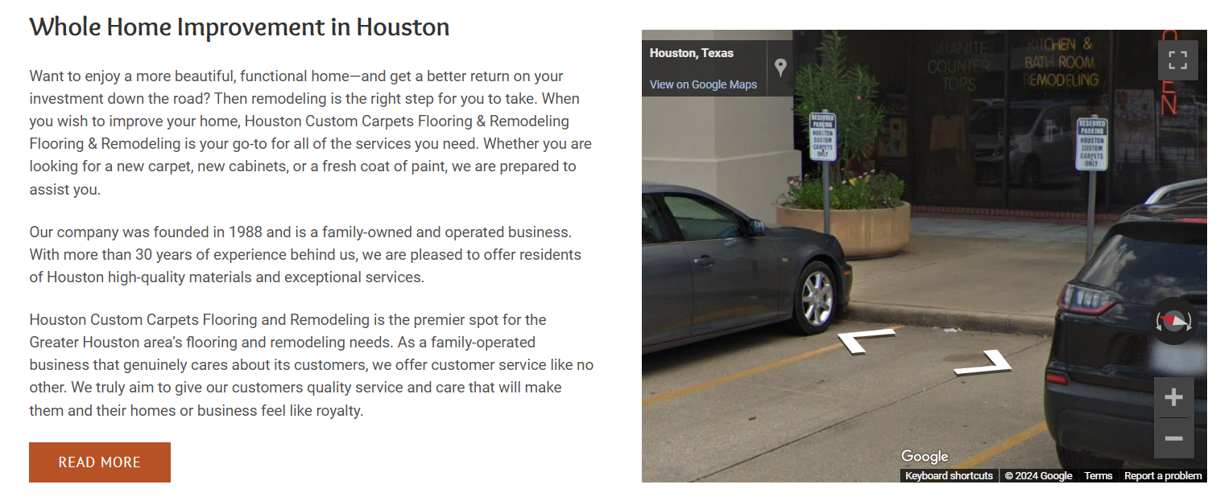Add New Life to Your Home in Houston (H2)

Just imagine walking into your home after a long day at work and seeing a new house where everything is designed to look more beautiful and elegant. Remodeling your home has never been an easy task, especially for those who have not been able to consult with Houston Custom Carpets. For more than 30 years of experience, we have served as a local family-owned Houston Remodeling Company to transform our client's commercial & Residential visions into reality.

No job is out of reach for our Remodeling Contractors, be it a large or a relatively smaller-scale project. From kitchens and bathrooms to living rooms, bedrooms, children’s rooms, or if you desire a full makeover of the house or commercial building, we have all the skills and quality materials to deliver your dream house or apartment. We offer complete home Construction services to Home Renovation Services.

If you want to select the most popular Remodeling & Construction company in Houston we are here to make your home as beautiful as you ever imagined. Don’t wait any longer, contact us today and let us develop your whole home improvement plan.



Our Home Remodeling & Construction Services (H2)
Realize the full value of your home with our unique Remodeling & Construction services, which will help create an absolutely exceptional experience. It’s time to create your living space, not just a home, but your comfort space for the next few years.

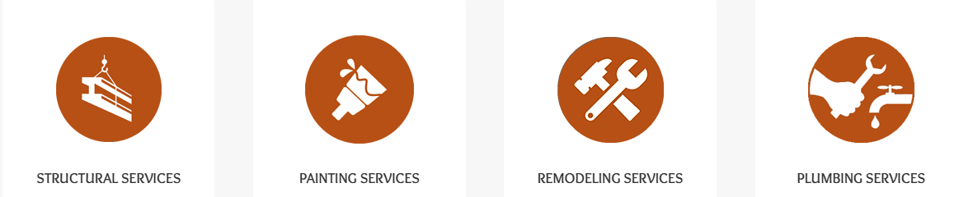

Home Remodeling | Kitchen Remodeling | Bathroom Remodeling
Our home remodeling solutions include all aspects of your living environment to make your house a true dream home for living. | Transform your cooking environment and skills with our professional kitchen renovation solutions, ideas, and installation services. | Remodel your bathroom to your desired ideal look to get your dream bathroom with a wide range of our bathroom renovation services.
Exterior Home Remodel | Flooring Services | Plumbing Houston
Improve the look of your house and add more usability to the home with our exterior contracting services to improve the overall look. | Give your home the flawless floor it deserves from our vast range of flooring options, skilled services, and quality workmanship. | Experience excellent Houston plumbing from our professional experts for consistent water flow and rapid problem-solving.
Painting Services | Structural Remodeling | Disaster Repair
Add a fresh look to your home by consulting with our paint experts who offer you many options for color choice, detail and texture. | Request structural remodeling from us and you will be able to change the layout of your home to make better use of the space as needed. | Expect efficiency and commitment when it comes to hurricane damage and other random acts of nature; have your house up in a short span.

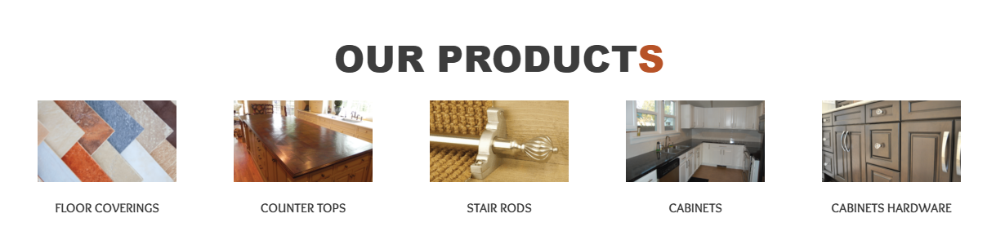

Our Products

FLOOR COVERINGS | COUNTER TOPS | STAIR RODS | CABINETS | CABINETS HARDWARE
Step up to the best luxury with the right floor covering beneath your feet! Our floor plans are full of a wide range of custom carpets, hardwood and tile that will bring out the best in your floors. | Make a statement with our tempting lineup of sophisticated and smooth countertops. Here, we have a variety of wonderful textures to meet your requirements and also to reveal your choice in style. | Looking for the best stair rods for your home then why not upgrade your style? All of our Stair Rods offer unique characteristics and super robustness to turn your stairs into an object of magnificence. | Unlock a myriad of design options with gorgeous custom cabinetry right here at your doorstep. From preference, with abundant storage to small kitchens, our cabinetry will upgrade your daily routine. | Finish your cabinetry project with our collection of beautiful cabinet hardware. Enjoy a wide selection of modern to traditional furniture with care and precision made to complement your ideal house.



Take a Step Up in Your Home Remodeling & Construction (H2)

As a leading General Remodeling Contractor in Houston, we provide the finest quality Residential & Commercial General Contracting Services in different areas of Houston. We aim to transform your home and commercial space with that elegant and bespoke look you’ve always wanted. It is now the perfect time to give some new heights to your home, with us.

